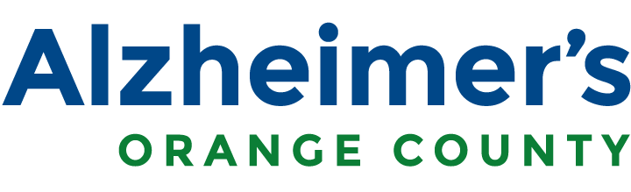

# E-Mail to Elected Officials

**Subject:** CBAS & ADHC Saves Lives

Governor Newsom’s revised budget for California calls for the elimination of funding for the critically important Adult Day Health Care/Community Based Adult Services (CBAS) program. The Adult Day Health Care model of multi-disciplinary care is proven to be an effective solution in the management of chronic conditions of older adults, saving money and enhancing quality of life. Elimination of Adult Day Health Care/CBAS would cost California significantly more that would be saved due to cost-shifting of care to decidedly more expensive settings.

* Adult Day Health Care/CBAS centers are the **first line of defense** against hospitalization or institutional care for frail seniors.
* Adult Day Health Care/CBAS centers **alleviate the daytime burdens of caregiving** for family caregivers while ensuring that frail older adults receive **appropriate, safe, coordinated care from highly skilled professionals**. These centers allow family members to work, attend school, handle personal business and manage their own health, knowing their loved one is well cared for and safe.
* This measure is ill-advised and will NOT make economic sense. The average cost to the State for a CBAS participant is $2,200/month, compared to hospitalization or Skilled Nursing Facility costs of well over $6,000/month. **Adult Day Healthcare/CBAS has been proven to reduce hospital admissions by 60% over 12 months, and reduce Skilled Nursing Facility admissions by 70%**

# In Orange County alone, 17 Adult Day Health Centers serve an estimated 2,975 frail seniors. The projected funding cuts would force all 17 centers to close.

I urge you to let Governor Newsom know that eliminating the funding for Adult Day Health Care/CBAS Centers is bad for Orange County and bad for California.

Sincerely,

[Insert Full Name] [Insert Home Address] [Insert City, Zip code]